

Project PRN292

**HANA SHOP**

|  |  |
| --- | --- |
| **Group** | |
| **Group members** | Dang Hoang Son – SonDHSE130448  Tran Kha Gia – GiaTKSE130708 |
| **Supervisor** | Mr. Ho Hoan Kiem |

**Table of Contents**

1. **Introduction…………………………………………………………………………………………………………….3**
2. Project Information …………………………………………………………………………………………………….4
3. Introduction ……………………………………………………………………………………………………………….4
4. Problem Definition ……………………………………………………………………………………………………..4
5. Functional Requirement ……………………………………………………………………………………………..4
6. Hardware/Software Requirement………………………………………………………………………………..7
7. Role and Responsibility…………………………………………………………………………….………………….7
8. Software Project Management…………………………………………………………………………………….8
9. **Diagram…………………………………………………………………………………………………………………..9**
10. Use Case Diagram……………………………………………………………………………………………………….10
11. Class Diagram……………………………………………………………………………………………………………..16
12. Sequence Diagram……………………………………………………………………………….……………………..17
13. Entity Relationship Diagram………………………………………………………………………………………..21
14. Database Relationship Diagram…………………………………………………………………………………..22
15. **Review 3………………………………………………………………………………………………………………….26**
16. **Interface Design………………………………………………….…………………………………………………..27**
17. **Task sheet………………………………………………………………………………………………………………..35**

**Introduction**

1. **Project Information**

* Project name: Hana Shop - Online Food.
* Product type: Website.
* Start Date: February 28th 2020.
* End Date: April 04th2020.

1. **Introduction**

Hana shop is an online shop selling drinks/fast food. An application which is needed when everyone can not go out because of COVID-19.

* This project is a website that sells foods: coffee, cakes, candies,…
* The website supports online payment (PayPal) or cash payment upon delivery.
* Integrated Login by google, facebook.
* Integrated Messenger facebook to support user.

Url Web: <https://hanashop1.azurewebsites.net/>

1. **Problem definition**

Below are the advantages and disadvantages of Hana website :

* Advantage:
  + Easy to use.
  + Provide users many supports searching for product their expected.
  + User can send feedback to a noob product by chat direct with admin.
* Disadvantage:
  + Can response slowly because internet.
  + Can not run with the best performance on all browser.

1. **Functional Requirement**

Function requirements of the system are listed as below:

1. **Function 1: Login**   
   o In order to shopping, an authentication is required.  
   o If the user has not authenticated, the system display the login popup.  
   o The actor enters username and password, the function checks if the username with the password is in the available user list, then grant the access permission. If not, a message would appear to notify that user is not found.  
   o Login function includes logout and welcome functions.

o Login function is required to shopping.

1. **Function 2: Registration**  
   o Registration a new account: username, email, full name, password.  
   o The default role of new account is user.
2. **Function 3: Details User.**  
   o User can view details of them self.  
   o Admin can view details of a user.
3. **Function 4: Update User.**

o User can update details of them self : full name, avatar, description and email.

o Admin can update details of a user include role.

1. **Function 5: Search Foods/ Drinks**   
   o List first 9 available items in the system order by date (status is Stocking and quantity greater than 0). Paging is required to use.  
   o Each food has a name, image, description, price, …  
   o User can find the food based on name or range of money or category or kind.  
   o All users can use this function (login is not required).
2. **Function 6: View 3 New Products**

o Show 3 new products.

o All users can use this function (login is not required).

1. **Function 7: View Details Product**

o View details of a products.

o All users can use this function (login is not required).

1. **Function 8: Shopping**  
   o Add the selected Food to shopping cart. The default quantity is 1.  
   o Each user can buy any available Food in the list.

o User can view the selected Food in the cart. For each Food: Food name, amount, price, total. The screen must show the total amount of money of this cart.

o User can remove the Food from the cart. The confirm message will show before delete action.  
o User can update amount of each Food in cart.  
o Click the Confirm button to store the Food to database (must store the buy date time). The warning message will show if the selected Food is out of stock.  
o The default payment is cash payment upon delivery.  
o All users can use this function except Admin role  
o Login is required.

1. **Function 9: Send mail to user about the payment.**

o Send mail to user the details of the order to notify to user that order is success .

1. **Function 10: Integrate online payment**

o User can pay online via Paypal.

1. **Function 10: Shopping history**   
   o User can take over the shopping history after payment.
2. **Function 11: Login extra**  
   o Integrated login using Google email.

o Integrated login using Facebook.

1. **Function 12: Integrate Messenger Facebook**  
   o Integrated Messenger Facebook for users to chat directly with admin.

o All users can use this function (login is not required).

1. **Function 13: Create product**  
   o Create new Food.  
   o Import date is current date.  
   o The default status of new Food is active.  
   o Only Admin role has permission to do this function.
2. **Function 14: Update Product**   
   o Update information of the selected food: name, image, price, category, quantity,...  
   o Update list Food after update.  
   o The system must record the update date, update user.  
   o Only Admin role has permission to do this function.
3. **Function 15: Delete Product**o The confirm message will show before delete action.  
   o Update list food after delete.  
   o Delete action is update the status of the Food to STOP.  
   o The system must record the update date, , update user.  
   o Only Admin role has permission to do this function.
4. **Function 16: Create account**   
   o Create new Account.  
   o Import created date is current date.  
   o Only Admin role has permission to do this function.
5. **Function 17: Update Account**   
   o Update information of the selected Account: full name, email, avatar, description and role.  
   o Update list Account after update.  
   o Only Admin role has permission to do this function.
6. **Function 18: Manage Dashboard**   
   o Admin can view the graph which is showing the revenue, number of bill of each 7 days, product in storage.
7. **Function 19: Show error page and auto send email notify error to developer**

o When server occurs error, server will redirect response to error page.  
o If error code different of 404, server will send email for notifying this error to developers.

# Hardware/ Software Requirements

By adding new technologies such as ASP.NET 4.8, AJAX, JQUERY, Entity Framework, MVC 5 and 3-tier architecture, the web site becomes more interactive with users, security and easily updated.

**System Requirement**

* **For Users**
  + **Hardware**
    - CPU: Pentium IV 2.0 GHz or higher.
    - RAM: 4 GB or higher.
  + **Software**
    - OS: Windows 8 or higher.
    - Browser: Chrome, Microsoft Edge, Coc Coc.
* **For Software Developers**
  + **Hardware**
    - CPU: Pentium IV 2.0 GHz or higher
    - RAM: 8 GB or higher
  + **Software**
    - OS: Windows 10 professional
    - Environment: Microsoft .NET Framework 4.8
    - Database Management System: Microsoft SQL Server 2017 or Higher
    - IDE: Microsoft Visual Studio 2019
    - Web Server: Internet Information Services (IIS).
    - Browser: Chrome, Microsoft Edge, Coc Coc

# Role and Responsibility

|  |  |  |  |  |
| --- | --- | --- | --- | --- |
| **No** | **Full Name** | **Role** | **Position** | **Contact** |
| **1** | Dang Hoang Son | Developer | Leader | [sonhoang1809@gmail.com](mailto:sonhoang1809@gmail.com) |
| **2** | Tran Kha Gia | Developer | Member | [giatkt1598@gmail.com](mailto:giatkt1598@gmail.com) |

# Software Project Management

1. **Software Process Model**

Project is developed under modified Agile model

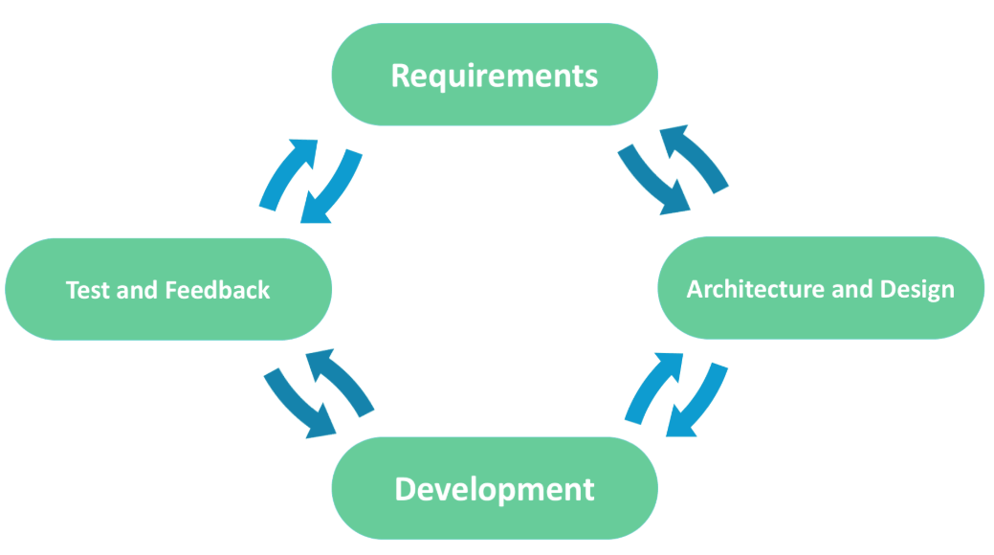

1. **Tools and Techniques**

- Tool: Visual Studio 2017, 2019.

* + - Front-end technologies: HTML, CSS, JavaScript, jQuery, AJAX.
    - Back-end:
* Website: ASP.NET MVC5 + Entity Framework .
* Scheduler: Azure DevOps backlog.
* Parse data from website: LINQ.
  1. **When coding:**
     + Web server: Microsoft IIS.
     + Database server: SQL Server 2017, 2019 (Localhost)
     + Database Management System: Microsoft SQL Server Management Studio 2018, Azure Studio.
  2. **When release:**
  + Web server: Azure web service.
  + Database server: Azure SQL Server.
  + Database Management System: Microsoft SQL Server Management Studio 2018, Azure Studio.

**DIAGRAM**

1. **Use case diagram**
   1. **Use Case**

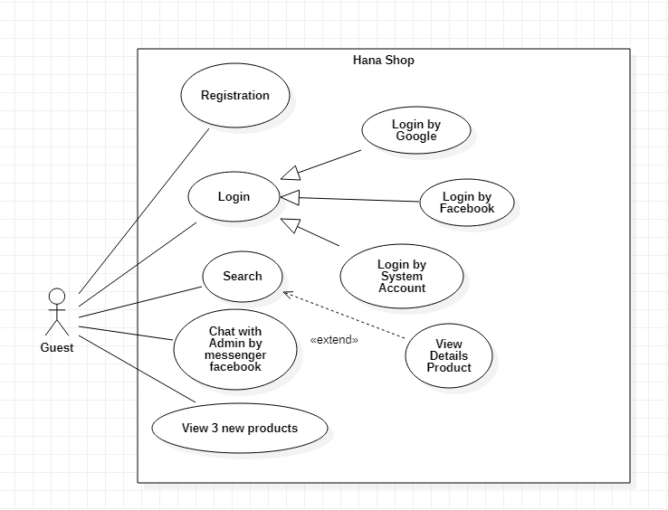

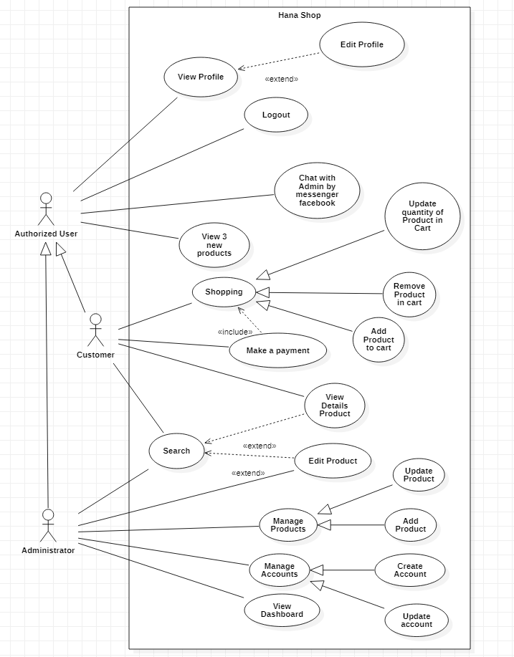

* 1. **Use case description**
     1. **Actor:**
        1. **Guest:** is the person that uses this website but doesn’t register.
        2. **Authorized user**: is the person that uses this account and have account, that include use case of guest.
        3. **Customer**: the default role when register.
        4. **Administrator**: The person(s) that manage and maintain this web site.
     2. **Use case**:

|  |  |
| --- | --- |
| **Use case** | Register |
| **Short Description** | Register account to become a customer of the web site. |
| **Pre-Conditions** |  |
| **Post-Conditions** |  |
| **Main flow** | _Guest must provide mandatory information :   * User name * Full name * Password * Confirm Password * Email   _Guest provides supplementary information : User name, Full name, Password, Email  _Guest clicks on Sign up button.  _System checks the information which guest provided.  _System create new account for guest that registers to this website.  _Guest becomes a customer of this website. |
| **Alternative flow(s)** | _If the mandatory information that guest provided, is missed or not exactly, system notifies the error. All cases are :   * User name has existed in database. * Username is less than 2 characters or more than 64 characters. * Username is incorrect format (allowed characters: a-z, A-z, 0-9). * Password is less than 6 characters or more than 64 characters. * Confirm Password and Password are not match. * Email is invalid or has existed in database. * Any fields are blank.   _System must be insert the date that guest register to become customer.  _If server notifies any error when it’s processing, system will send mail to admin about this error. |

|  |  |
| --- | --- |
| **Use case** | Login |
| **Short Description** | Log in website to use any function of customer/administrator. |
| **Pre-Conditions** |  |
| **Post-Conditions** |  |
| **Main flow** | _Guest inputs the login information :   * User name. * Password.   _Guest clicks on the Login button.  _System check the User name and Password.  _If User name and Password are valid, system will move authorized user to Homepage. |
| **Alternative flow(s)** | _If Login ID field or Password field is invalid form or blank when guest clicks on the “Login” button, system will notify the error.  _If server notifies any error error when it’s processing, system will send mail to admin about this error. |

|  |  |
| --- | --- |
| **Use case** | View Profile User |
| **Short Description** | View the Profile of User. |
| **Pre-Conditions** | User login to the system |
| **Post-Conditions** |  |
| **Main flow** | _User click to view profile.  _System display the profile of user. |
| **Alternative flow(s)** | _If server notifies any error when it’s processing, system will send mail to admin about this error. |

|  |  |
| --- | --- |
| **Use case** | Update Profile |
| **Short Description** | Update the Profile of User. |
| **Pre-Conditions** | User login to the system, click View Profile |
| **Post-Conditions** |  |
| **Main flow** | _User update their information: full name, description, avatar,....  _System checks the information which user provided.  _System update information for user. |
| **Alternative flow(s)** | _If the mandatory information that user provided, is missed or not exactly, system notifies the error. All cases are :   * Password is less than 6 characters or more than 30 characters. * Any fields are blank.   _If server notifies any error when it’s processing, system will send mail to admin about this error. |

|  |  |
| --- | --- |
| **Use case** | Search |
| **Short Description** | Every user can search. |
| **Pre-Conditions** |  |
| **Post-Conditions** |  |
| **Main flow** | _User choose a condition about the product they want to see.  _ Clicks Search Button.  _System search this condition in database and show the list product to client. |
| **Alternative flow(s)** | _If there are no product. System will this play notify that “No products”.  _If server notifies any error when it’s processing, system will send mail to admin about this error. |

|  |  |
| --- | --- |
| **Use case** | View News Product |
| **Short Description** | View the new products. |
| **Pre-Conditions** |  |
| **Post-Conditions** |  |
| **Main flow** | _User access to the website.  _If customer want to see the details of new, he(she) clicks on the link of this new. All content of a new product will be shown. |
| **Alternative flow(s)** | _If server notifies any error when it’s processing, system will send mail to admin about this error. |

|  |  |
| --- | --- |
| **Use case** | View Details Product |
| **Short Description** | View the details of product. |
| **Pre-Conditions** |  |
| **Post-Conditions** |  |
| **Main flow** | _User click View details button.  _System checks the product is available.  _System show the product is available if it available. |
| **Alternative flow(s)** | _System show the message that “product is not available in stock” if it’s status code is not “STOC”.  _If server notifies any error when it’s processing, system will send mail to admin about this error. |

|  |  |
| --- | --- |
| **Use case** | Support User |
| **Short Description** | Chat directly with admin |
| **Pre-Conditions** | User have account facebook. |
| **Post-Conditions** |  |
| **Main flow** | Customers can contact with the admin by messenger facebook. |
| **Alternative flow(s)** | _If server notifies any error when it’s processing, system will send mail to admin about this error. |

|  |  |
| --- | --- |
| **Use case** | Manage Account |
| **Short Description** | Manage all information user. |
| **Pre-Conditions** |  |
| **Post-Conditions** |  |
| **Main flow** | _Manage all information of user. (CRUD) |
| **Alternative flow(s)** | _If server notifies any error when it’s processing, system will send mail to admin about this error. |

|  |  |
| --- | --- |
| **Use case** | Manage Product |
| **Short Description** | Manage all information product. |
| **Pre-Conditions** |  |
| **Post-Conditions** |  |
| **Main flow** | _Manage all information of product. (CRUD) |
| **Alternative flow(s)** | _If server notifies any error when it’s processing, system will send mail to admin about this error. |

1. **Class diagram**

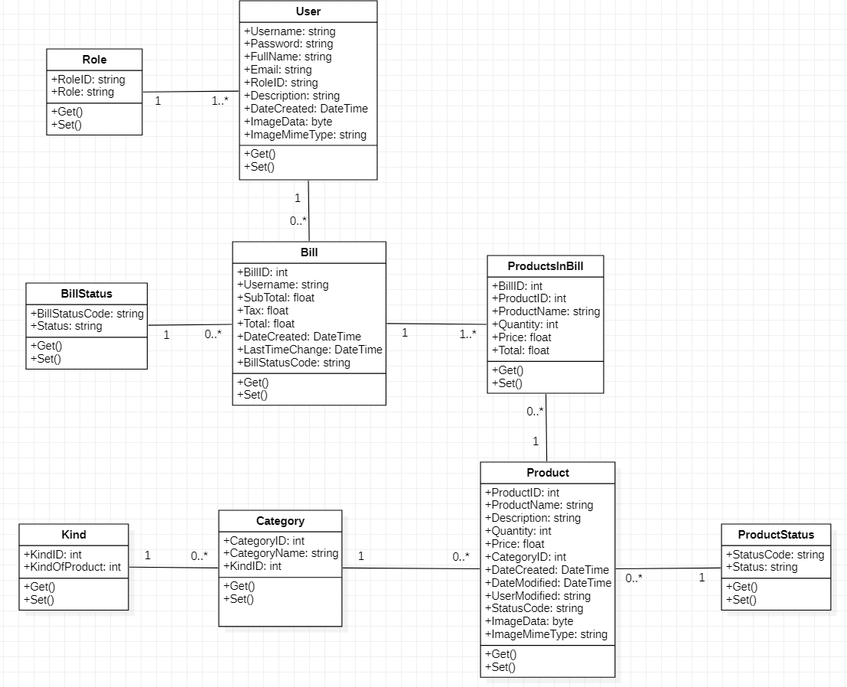

1. **Sequence Diagram**
   1. **Login**

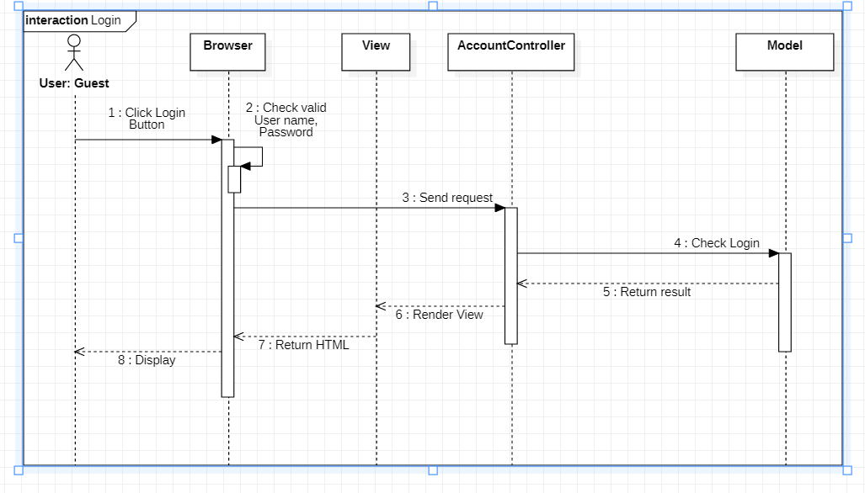

* 1. **Search**

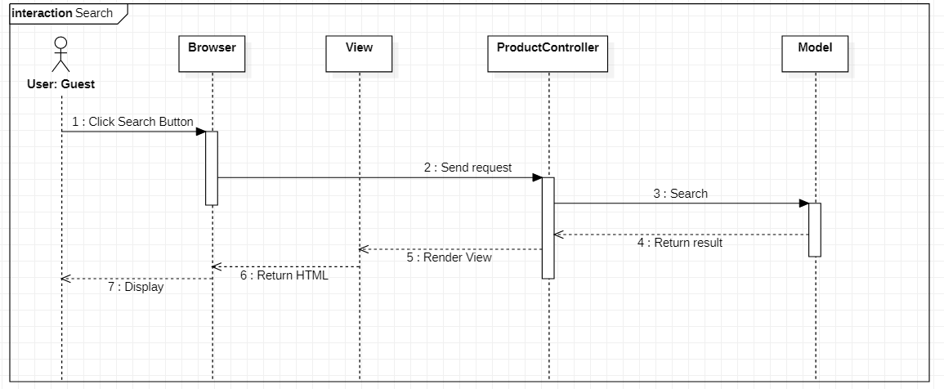

* 1. **Register**

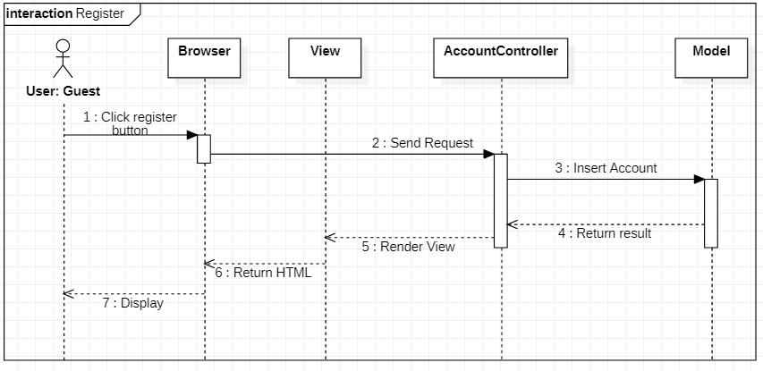

* 1. **Logout**

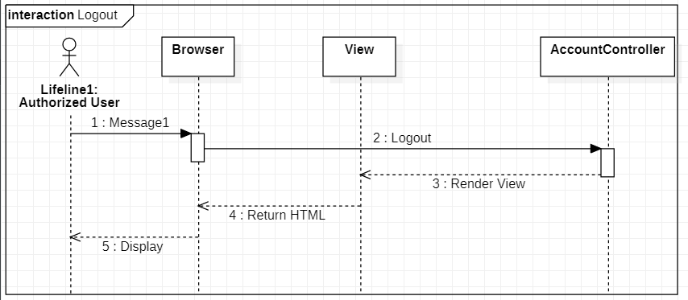

* 1. **View details product**

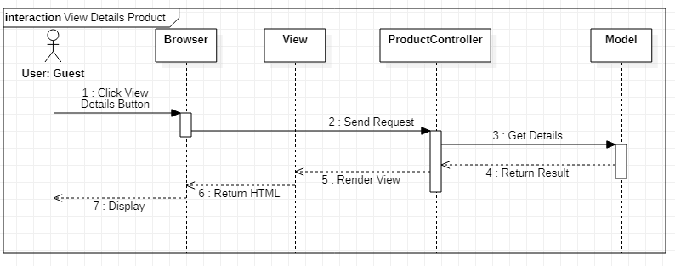

* 1. **Add product to cart**

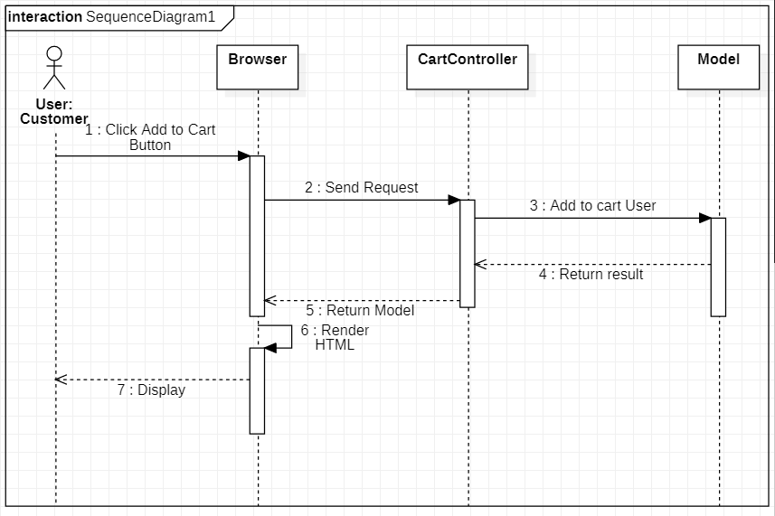

1. **Entity Relationship Diagram**

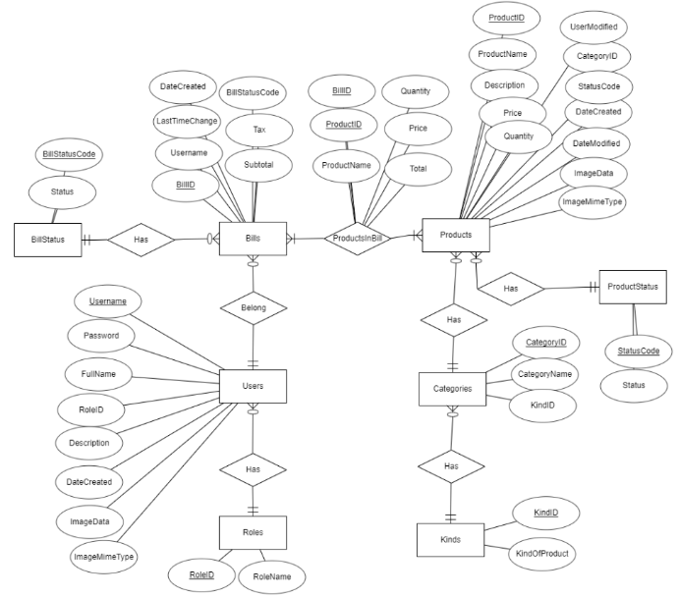

1. **Database Relationship Diagram**

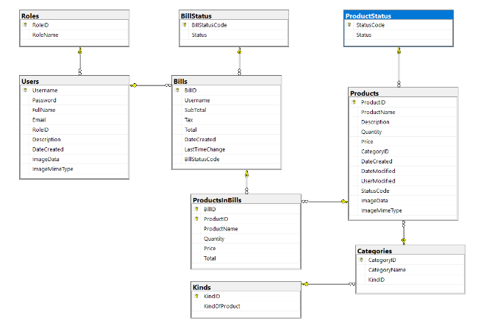

**TABLE DESIGN**

1. **Users :**

|  |  |  |  |  |  |
| --- | --- | --- | --- | --- | --- |
| **No** | **Column Name** | **Data Type** | **Size** | **Check** | **Description** |
| **1** | 🔑**Username** | **varchar** | **64** | **Not Null** | **Username for signing in** |
| **2** | **Password** | **varchar** | **64** | **Not Null** | **user’s password** |
| **3** | **FullName** | **nvarchar** | **250** | **Not Null** | **User ’s full name** |
| **4** | **Email** | **varchar** | **250** | **Null** | **Email user** |
| **5** | **RoleID** | **varchar** | **2** | **Not Null** | **User’s role ID** |
| **6** | **Description** | **nvarchar** | **MAX** | **Null** | **User’s description** |
| **7** | **DateCreated** | **Date** |  | **Not Null** | **Date Created User** |
| **7** | **ImageData** | **varbinary** | **MAX** | **Null** | **User’s avatar data** |
| **8** | **ImageMimeType** | **nvarchar** | **100** | **Null** | **User’s avatar type** |

1. **RoleID :**

|  |  |  |  |  |  |
| --- | --- | --- | --- | --- | --- |
| **No** | **Column Name** | **Data Type** | **Size** | **Check** | **Description** |
| **1** | 🔑**RoleID** | **varchar** | **2** | **Not Null** |  |
| **2** | **RoleName** | **varchar** | **10** | **Not Null** |  |

1. **Products :**

|  |  |  |  |  |  |
| --- | --- | --- | --- | --- | --- |
| **No** | **Column Name** | **Data Type** | **Size** | **Check** | **Description** |
| **1** | 🔑**ProductID** | **int** | **Identity** | **Not Null** | **ID** |
| **2** | **ProductName** | **nvarchar** | **MAX** | **Not Null** | **Name of product** |
| **3** | **Description** | **nvarchar** | **MAX** | **Not Null** | **Description of product** |
| **4** | **Quantity** | **int** |  | **Not Null** | **Quantity of product** |
| **5** | **Price** | **float** |  | **Not Null** | **Price of product** |
| **6** | **CategoryID** | **int** |  | **Not Null** | **CategoryID of product** |
| **7** | **DateCreated** | **date** |  | **Not Null** | **Date created of product** |
| **8** | **DateModified** | **datetime** |  | **Null** | **Last time updated of product** |
| **9** | **UserModified** | **nvarchar** | **MAX** | **Null** | **Full name of latest admin who is updated product** |
| **10** | **StatusCode** | **varchar** | **4** | **Not Null** | **Status code of product** |
| **11** | **ImageData** | **varbinary** | **MAX** | **Null** | **Image data of product** |
| **12** | **ImageMimeType** | **nvarchar** | **100** | **Null** | **Type of image** |

1. **ProductStatus:**

|  |  |  |  |  |  |
| --- | --- | --- | --- | --- | --- |
| **No** | **Column Name** | **Data Type** | **Size** | **Check** | **Description** |
| **1** | 🔑**StatusCode** | **Varchar** | **4** | **Not Null** | **Status code of product** |
| **2** | **Status** | **nvarchar** | **30** | **Not Null** | **Status name of product** |

1. **Bills:**

|  |  |  |  |  |  |
| --- | --- | --- | --- | --- | --- |
| **No** | **Column Name** | **Data Type** | **Size** | **Check** | **Description** |
| **1** | 🔑**BillID** | **int** | **Identity** | **Not Null** | **ID** |
| **2** | **Username** | **varchar** | **64** | **Not Null** | **Username of owner’s bill** |
| **3** | **SubTotal** | **float** |  | **Not Null** | **Sub total** |
| **4** | **Tax** | **float** |  | **Not Null** | **Tax** |
| **5** | **Total** | **float** |  | **Not Null** | **Bill’s total** |
| **6** | **DateCreated** | **datetime** |  | **Not null** | **Bill’s date created** |
| **7** | **LastTimeChange** | **datetime** |  | **Null** | **Bill’s last time change** |
| **8** | **BillStatusCode** | **varchar** | **3** | **No null** | **Bill’s status code** |

1. **BillStatus :**

|  |  |  |  |  |  |
| --- | --- | --- | --- | --- | --- |
| **No** | **Column Name** | **Data Type** | **Size** | **Check** | **Description** |
| **1** | 🔑**BillStatusCode** | **varchar** | **3** | **Not Null** | **Bill’s status code** |
| **2** | **Status** | **nvarchar** | **MAX** | **Not Null** | **Bill’s status name** |

1. **ProductsInBills :**

|  |  |  |  |  |  |
| --- | --- | --- | --- | --- | --- |
| **No** | **Column Name** | **Data Type** | **Size** | **Check** | **Description** |
| **1** | 🔑**BillID** | **int** |  | **Not Null** | **Bill’s ID** |
| **2** | 🔑**ProductID** | **int** |  | **Not Null** | **Product’s ID** |
| **3** | **ProductName** | **nvarchar** | **MAX** | **Not Null** | **Product’s name** |
| **4** | **Quantity** | **int** |  | **Not null** | **Quantity of product** |
| **5** | **Price** | **float** |  | **Not Null** | **Price of product** |
| **6** | **Total** | **float** |  | **Not Null** | **Total = Quantity * Price** |

1. **Categories :**

|  |  |  |  |  |  |
| --- | --- | --- | --- | --- | --- |
| **No** | **Column Name** | **Data Type** | **Size** | **Check** | **Description** |
| **1** | 🔑**CategoryID** | **int** | **Identity** | **Not Null** | **Category ID** |
| **2** | **CategoryName** | **nvarchar** | **MAX** | **Not Null** | **Category name** |
| **3** | **KindID** | **int** |  | **Not null** | **Kind’s ID** |

1. **Kinds:**

|  |  |  |  |  |  |
| --- | --- | --- | --- | --- | --- |
| **No** | **Column Name** | **Data Type** | **Size** | **Check** | **Description** |
| **1** | 🔑**Kinds** | **int** | **Identity** | **Not Null** | **Kind’s ID** |
| **2** | **KindOfProduct** | **nvarchar** | **MAX** | **Not Null** | **Kind’s name** |

**Note**

🔑**Primary key**

**✔ Unique constraint**

**REVIEW 3**

**INTERFACE DESIGN**

**Home Page**

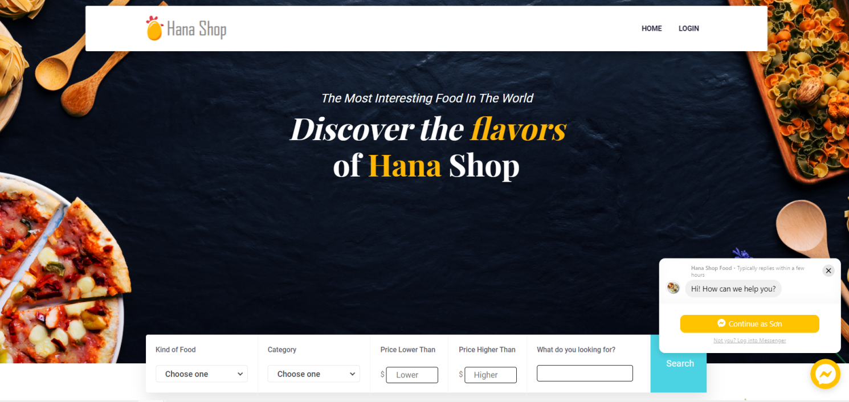

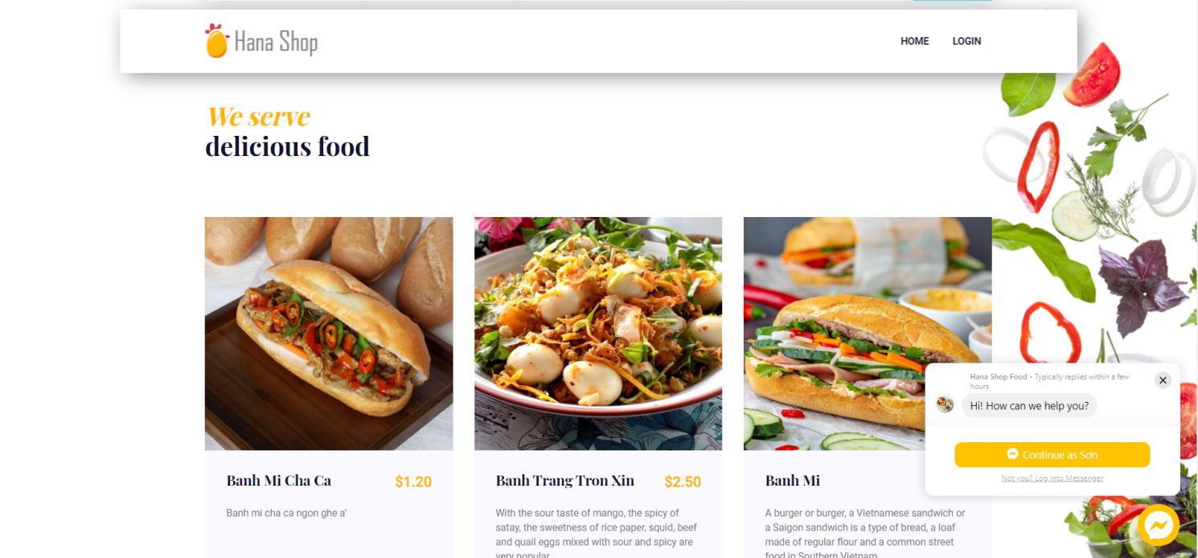

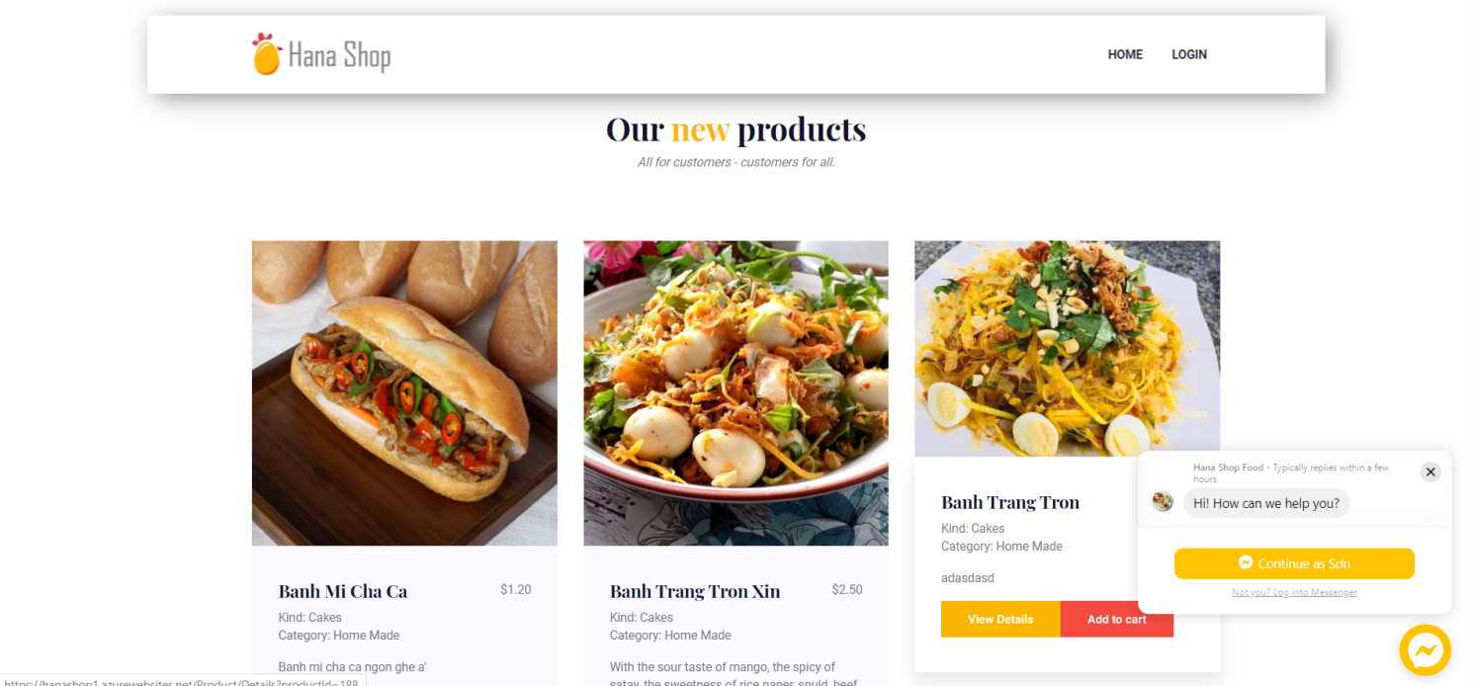

**Login Popup:**

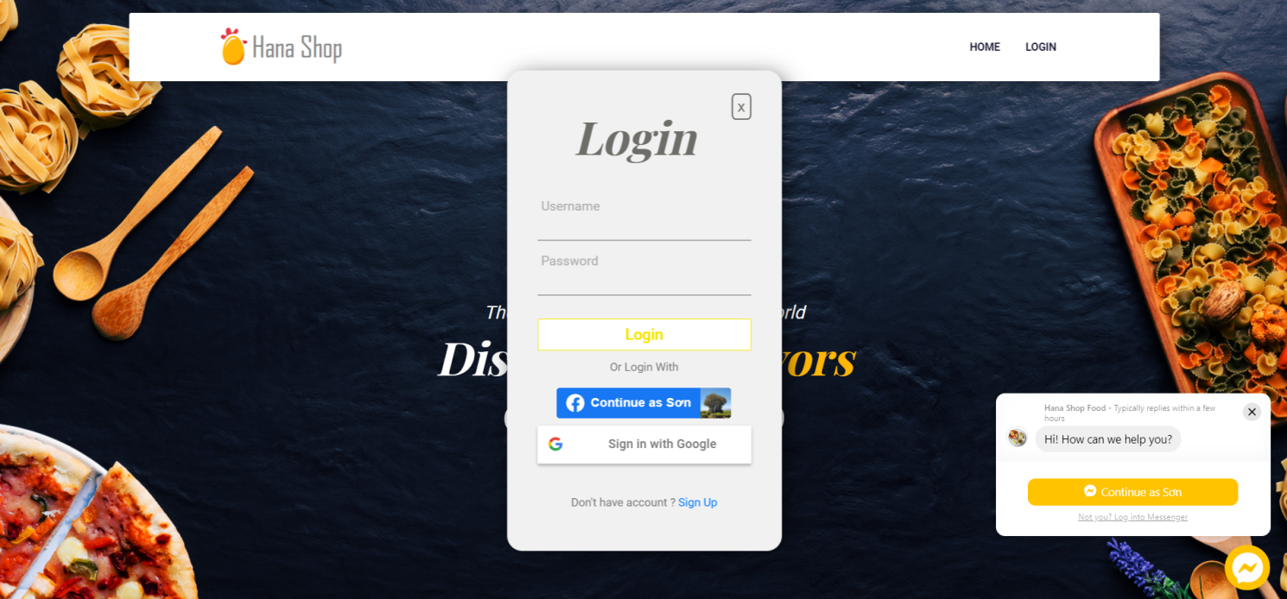

|  |  |  |  |  |  |
| --- | --- | --- | --- | --- | --- |
| **Name** | **Type** | **Event** | **Validation** | **Description** | **Status** |
| User Name | TextBox |  | String, not null | Input Customer’s user name |  |
| Password | TextBox |  | String, not null, | Input Customer’s password |  |
| Login | Button |  | Click | Login |  |

**Register Account Customer:**

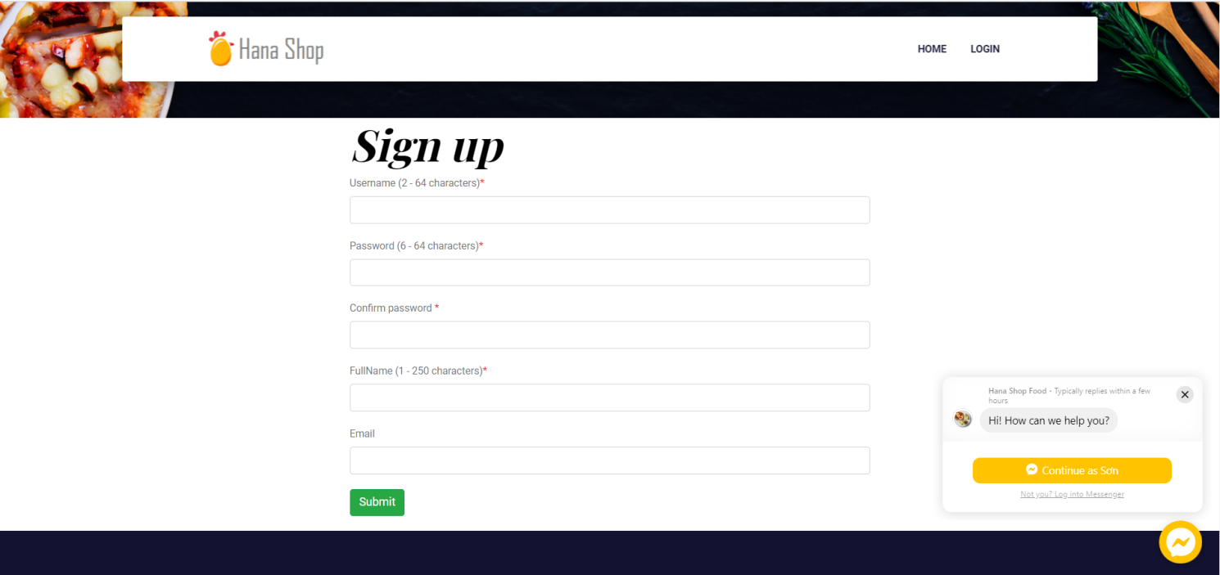

|  |  |  |  |  |  |
| --- | --- | --- | --- | --- | --- |
| **Name** | **Type** | **Event** | **Validation** | **Description** | **Status** |
| UserName | TextBox |  | String, not null, allowed character: a-z, A-Z, 0-9, 2 - 64 characters | Input UserName Customer |  |
| Password | TextBox |  | String, not null, 6 - 64 characters | Input Customer’s New password |  |
| Confirm Password | TextBox |  | String,not null | Input Customer’s Confirm Password |  |
| Full Name | TextBox |  | String, not null, 1 - 250 characters | Input Full Name Customer |  |
| Email | TextBox |  | String ,not null, have Validation | Input Email Customer |  |
| Submit | Button |  | Click | Register Customer |  |

**Product with the same type.**

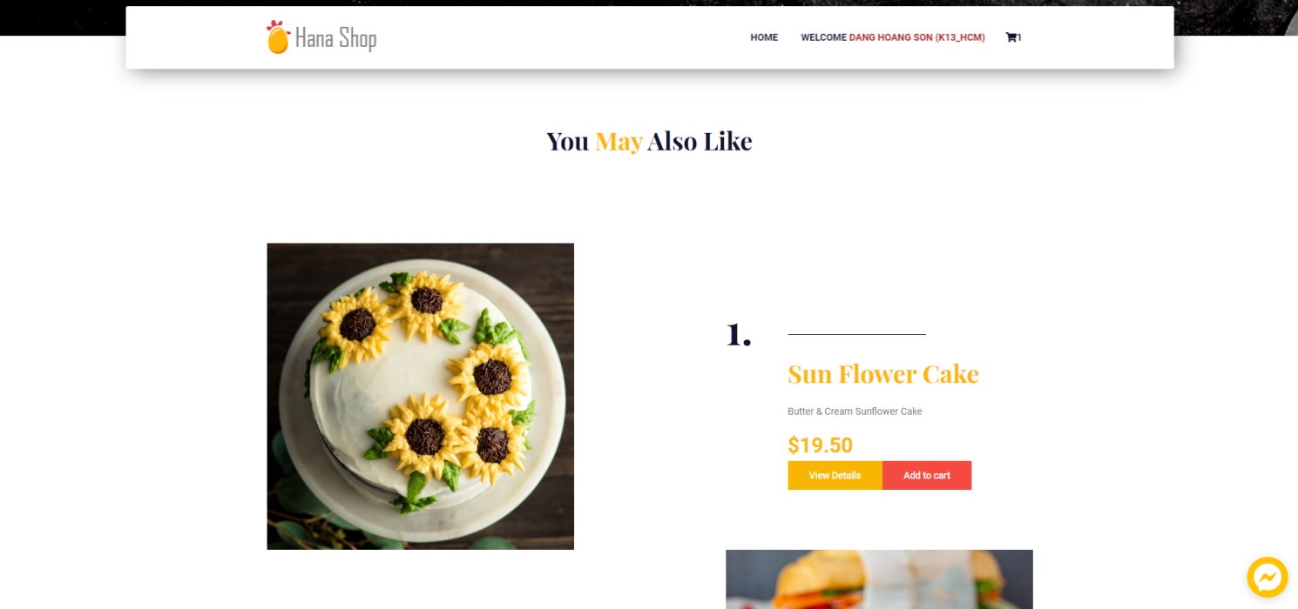

**Shopping Cart Hover:**

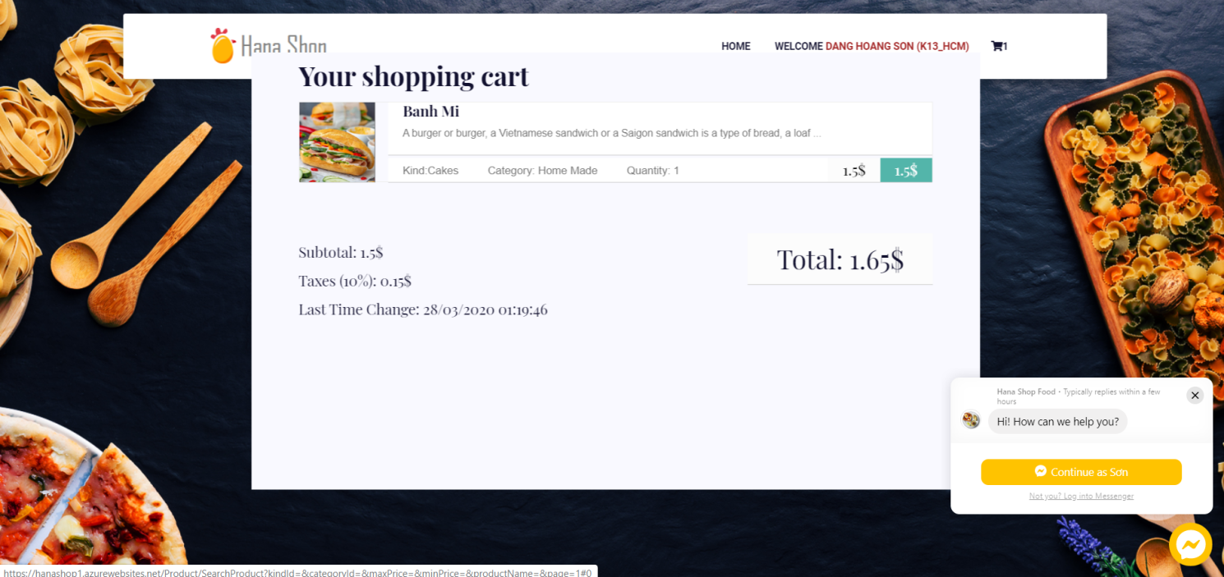

**Shopping Cart details**

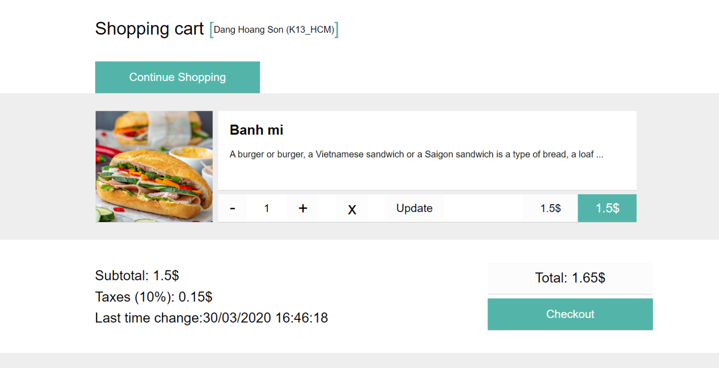

**Check Out**

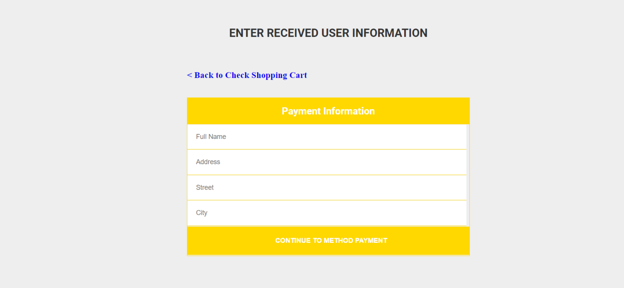

**Payment method**

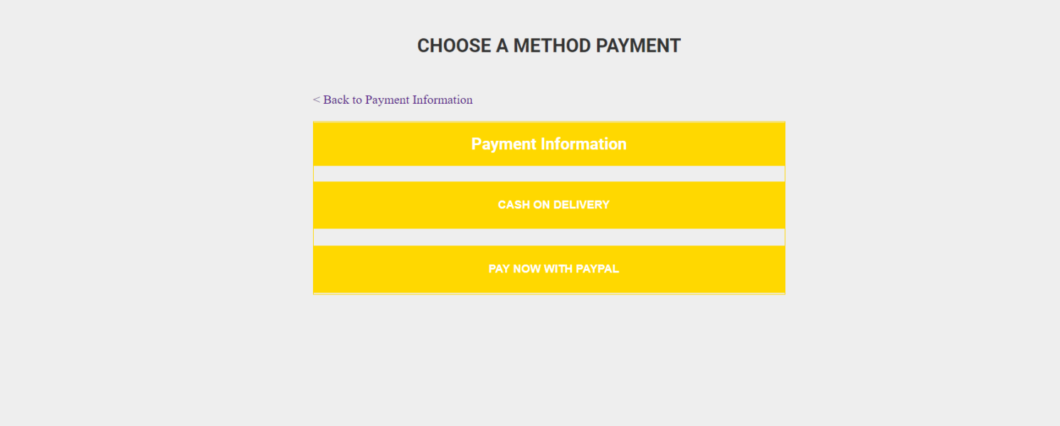

**Admin dashboard**

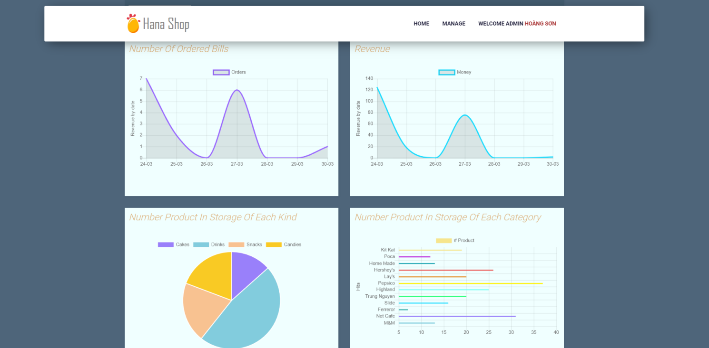

**Manage Product**

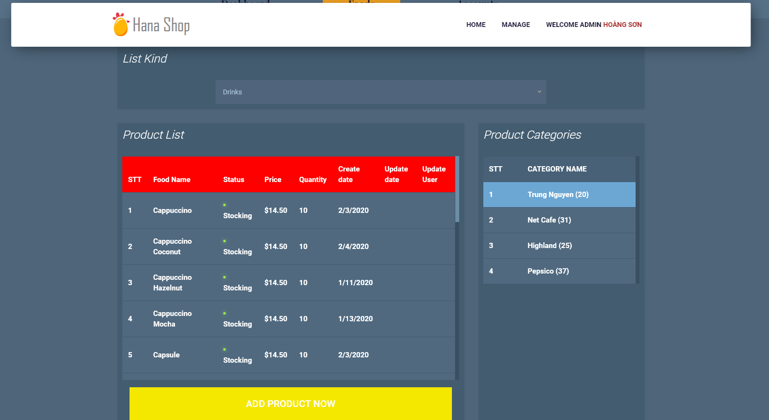

**Manage Account**

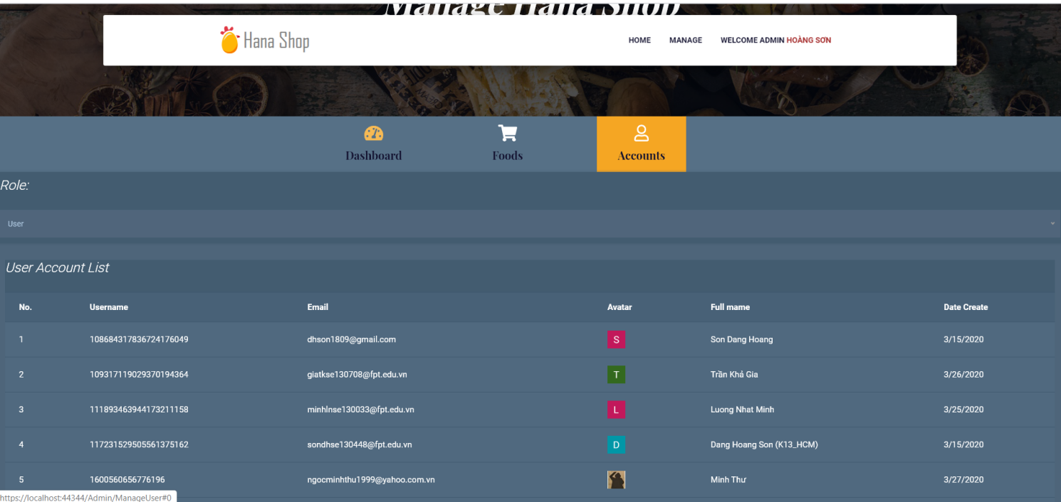

**Edit Profile**

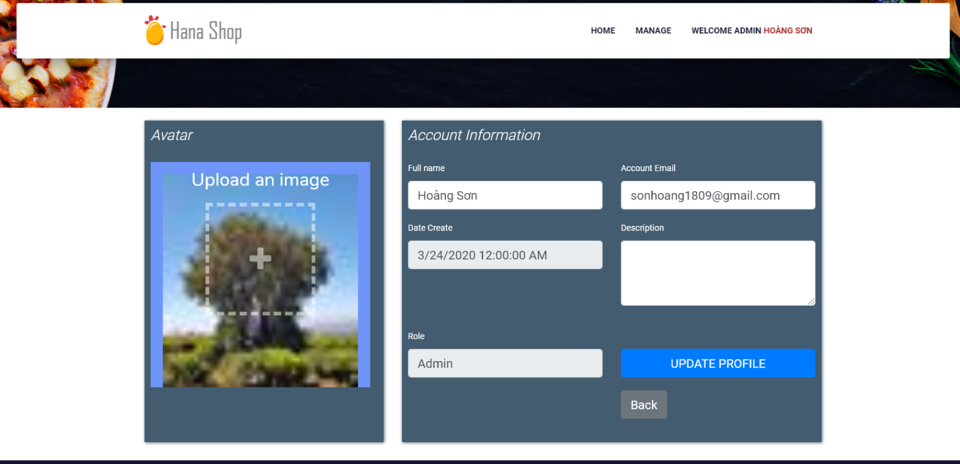

**TASK SHEET**

|  |  |  |  |  |  |  |
| --- | --- | --- | --- | --- | --- | --- |
| **Project Group** | | **Project Title**  **Hana Shop Online** | | **Date of Preparation** | | **Activity Plan Prepared by**  **Dang Hoang Son** |
| **No** | **Task Title** | | **Planned Start Date** | **Planned Completed Date** | **Team Mate Names** | **Status** |
| 1 | Product (View Product and Product Detail) | | Feb 20, 2020 | Mar 30, 2020 | **Tran Kha Gia** | Done |
| 2 | Manage Products | | Done |
| 3 | Search Product | | Done |
| 4 | Manage Account | | Done |
| 5 | Login, Logout | | Done |
| 6 | Display News | | Done |
| 7 | Login system account | | Done |
|  |  | | Done |
|  |  | | Done |
|  |  | | Done |
|  |  | | Done |
|  |  | | Done |
|  |  | | Done |
| 8 | UI | | **Dang Hoang Son** | Done |
| 9 | Display | | Done |
| 10 | Manage dashboard | | Done |
| 11 | Shopping cart | | Done |
| 12 | Modify Search | | Done |
| 15 | Order Product | | Done |
| 16 | Manage Orders | | Done |
| 17 | Send mail user’s orders | | Done |
|  | Report Interface Design | | Done |
|  | Modify paging | | Done |
|  | Report Use Case | | Done |
|  | Report Class Diagram | | Done |
|  | Report Sequence Diagram | | Done |
|  | Report Sprint Backlog | | Done |